## Merchant

Demo date: Nov 14, 2024  
Scoping start date: Nov 14, 2024

MSA Signature Date: Nov 14, 2024  
Onboarding Kick Off Date: Nov 14, 2024

[If Exists] Opt Out Date: Oct  
Go Live Date: Nov 14, 2024

GTM POC: Paula  
Implementation POC: Royce

ERP: QBO

Tax Integration: Anrok

### 

### Key people at Merchant

### Accountant: David - Velo CFO

### Head of Ops and Finance: Connor- Anysphere

* Account Receivable POC: Paul- Velo CFO
* COO- Jordan (I never met him)
* Emily- GTM - billing

### 

### 

| Notes Sections [Ops International Team to Ignore] *(AE/ Implementation to fill)*   * Info on how merchant bills   + Seats   + Model calls (future state)   + Overages: Prorate seats- quarterly true ups- actual vs contracted * Is there any important merchant relationship information? VELO CFO intro They have PLG and Ent. Ent biz is quickly growing   1) What is the merchant temperament?   They’re excited about us bc Velo CFO has put in a good word for us Connor met Rebecca in person   2) Is there a key POC: (i.e.: who is the buyer/decision maker?)  Connor  3) What are the Tabs features that the key POC cares about?   * Automated invoice creation * Will want to get a list of active customers exported from tabs (paying customers) * API for seats and usage calls * Ability to handle proration * Rev rec across entire business |
| --- |

### 

### Company summary *(AE to fill)*

Summary of what company does:  
AI-powered code editor that aims to boost developer productivity by using AI to analyze code, suggest improvements, and even generate code snippets based on natural language instructions.

Goals (North star)  
*(AE/ Implementation to fill)*

What is the merchant's goal? What pain are we solving? Why are they buying Tabs?

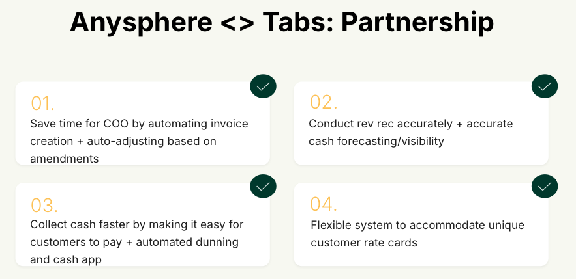  
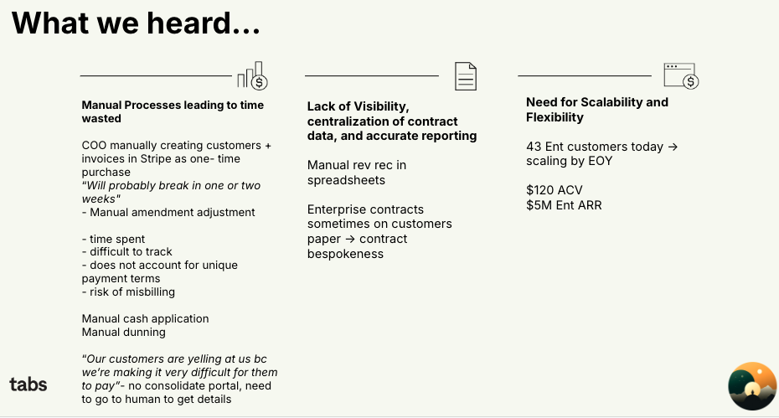

Is there an opt out clause? If so, what is the merchant looking for so they do not exercise it?

No

### Billing model *(AE/ Implementation to fill)*

* Are there unique things about the customer creation process for this merchant?

No

* Information on how merchant bills
* How contract is broken up
* One off things to know about the merchant  
    
  We presented implementation in 3 phases, with no timeline associated:  
  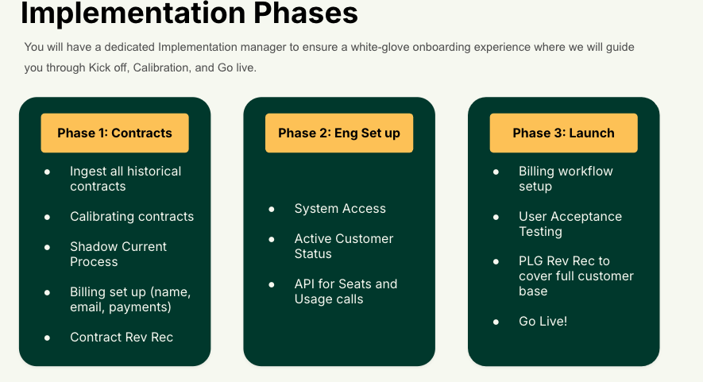  
    
  This was in order to buy time for us to build proration– they believe that we can handle proration.   
  They will likely purchase Metronome soon to meter usage, currently it’s in Redshift   
  They will want to do rev rec across all customers (PLG included)   
  They might bring up SSP in the future (not a concern now)

usage

### Contract Processing Steps *(Implementation/Success to fill)*

1. Steps to process
   1. Only process order forms.
   2. Check customer info. Default to billing information.
   3. Cursor Business
      1. Service Start Date: Order Form Effective Date
      2. Months of Service: 12
      3. Revenue Category: Platform
      4. Item Name: Cursor Business
      5. Item Description: Leave blank.
      6. Integration Item: Seat Charges
      7. Billing Type: Flat
      8. Total Price: Locate the total cost for the subscription, including per-seat pricing and any applicable discounts. (Standard is $384 x Seat Count Quantity)
      9. Quantity: Find the number of user seats/licenses included in the subscription.
      10. Start Date: Order Form Effective Date
      11. Periods: 1
      12. Frequency: 1 Year
      13. ~~Add 3 additional BTs for $0 each~~
          1. ~~9 month term starting 3 months later (Category: True up 1)~~
          2. ~~6 month term starting 6 months later (Category: True up 2)~~
          3. ~~3 month term starting 9 months later (Category: True up 3)~~
             1. ~~End date should be the same for all BTs~~
   4. Bug bot
      1. Integration item: Bug bot
   5. product name for usage moving forward to "On-demand Usage"
   6. ALL items need a revenue category.
      1. 1:1 match with the item name
      2. Create a ticket for Ashni if it is not available in the dropdown
      3. Cursor Seats from the first order form --> Platform
      4. Additional Cursor Seats →
      5. Historical Usage modeled as Flat BTs --> Usage
      6. Pre-committed or Pre-Paid usage credits --> Pre-Commit-Usage
      7. Platform Fee's that represent the Cursor Tokens --> Cursor Tokens
      8. Bug Bot Products --> Bug Bots
   7. **Add additional fields on the invoice page > Teams_id**
      1. **This id is usually at the top of the pdf**
   8. Don’t process BTs for waived or $0 line items
   9. Some BTs will be under “Usage-Based Pricing Fees”

* 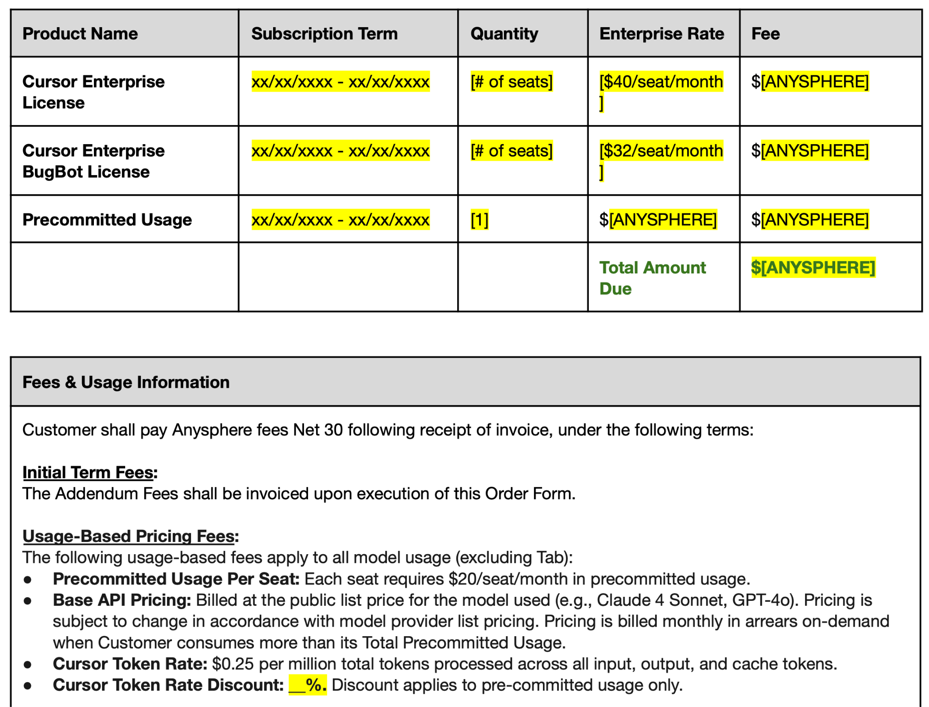
  1. Send slackbot once processed

1. Anything to ignore in contracts?
2. Specifics processing things the merchant has requested that may differ by contract (e.g. always back-date invoice date to final day of the month)
3. Default Service Term
   1. If None Listed, Ops Default is 1 Year
4. Default Net Payment Terms
   1. If None, Ops Default is 30
5. Default Billing Frequency
   1. If None Listed, Ops Default is Monthly
6. How do we handle taxes as a line item?
   1. If None Listed, Ops Default is every tax line item becomes a BT

### Events Processing (if necessary) *(Implementation/Success to fill)*

* Any important information on events billing

Integration Items Processing (if necessary)  
*(Implementation/Success to fill)*

* What are the instructions for assigning integration items?
* Example: All Statsig integrations items should be labeled as “Sales”
* Example: All “Pinata” integration items should be labeled as “Software Subscription Bundle” unless otherwise noted by Merchant

Post Processing Communications (if necessary)  
*(Implementation/Success to fill)*

* Does the Ops Team need to notify anyone on the team re: completion of processing batches in Implementation or Active phase?
* Who needs to be notified and when?

### Customer Information *(Implementation/Success to fill)*

### Feature Requests *(AE/Implementation/Success to fill)*

* FR 1
  + What is it
  + Why it's important
  + Urgency

### Rewatch Calls *(AE/Implementation/Success to fill)*

Intro <https://us-56595.app.gong.io/call?id=8081945719042410019>

Demo <https://us-56595.app.gong.io/call?id=578131066425730156&account-id=1346003462801771516>

Partnership <https://us-56595.app.gong.io/call?id=472611465206537794&account-id=1346003462801771516>